C PROGRAMMING
NAME: YOKITHA S
ROLL NO: 241801327
WEEK :5
TOPIC: NESTED LOOPS-WHILE AND FOR, JUMPS IN LOOPS
WEEK 5-1
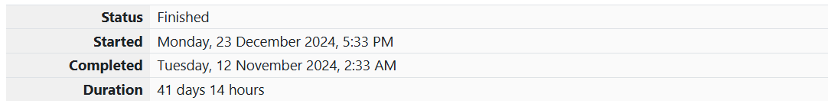
1. Problem Statement:
Write a program that prints a simple chessboard.
Input format:
The first line contains the number of inputs T.
The lines after that contain a different value for size of the chessboard
Output format:
Print a chessboard of dimensions size * size.
Print W for white spaces and B for black spaces.
Sample Input:
2
3
5
Sample Output:
WBW
BWB
WBW
WBWBW
BWBWB
WBWBW
BWBWB
WBWBW
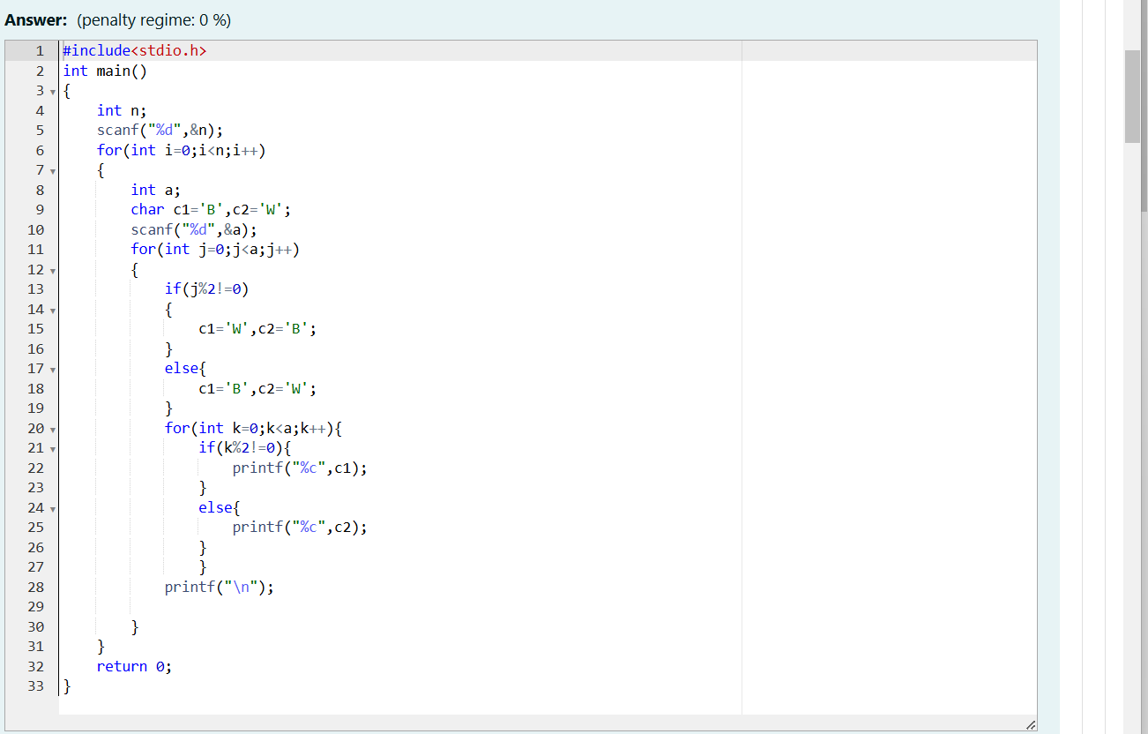
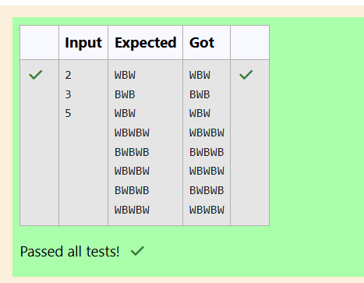
2. Problem Statement:
Let’s print a chessboard!
Write a program that takes input:
The first line contains T, the number of test cases
Each test case contains an integer N and also the starting character of the chessboard
Output Format
Print the chessboard as per the given examples
Sample Input:
2
2 W
3 B
Sample Output:
WB
BW
BWB
WBW
BWB
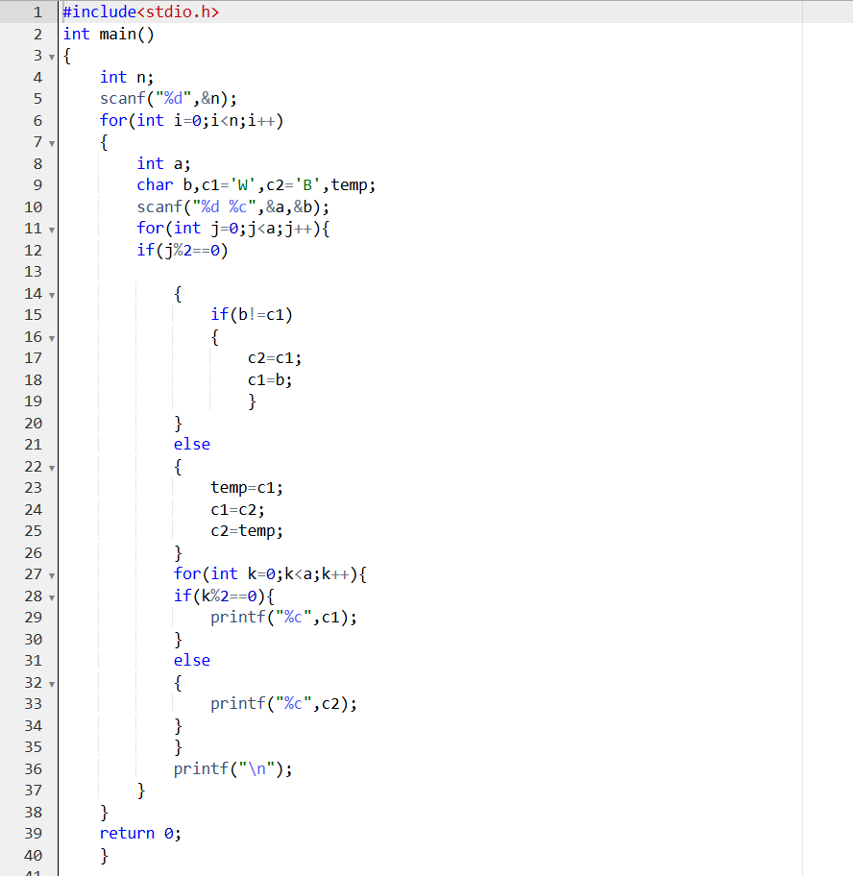
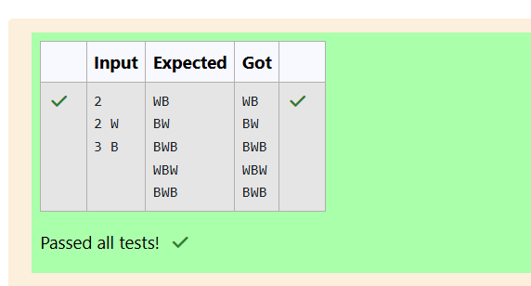

3. Problem 1: Pattern Printing
Problem Statement:
Decode the logic and print the pattern that corresponds to the given input.
Example:
- If N=3N = 3N=3, the pattern will be:
markdown
Copy code
10203010011012
**4050809
****607
- If N=4N = 4N=4, the pattern will be:
markdown
Copy code
1020304017018019020
**50607014015016
****809012013
******10011
Constraints:
2≤N≤1002 \leq N \leq 1002≤N≤100
Input Format:
- The first line contains TTT, the number of test cases.
- Each test case contains a single integer NNN.
Output Format:
- Print the pattern for each test case.

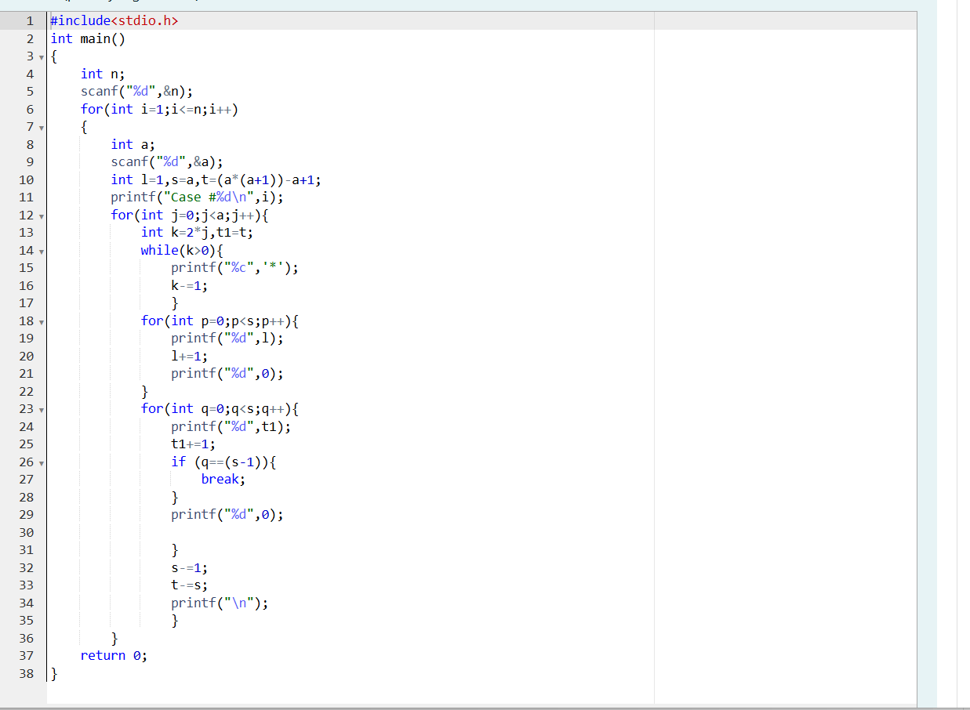
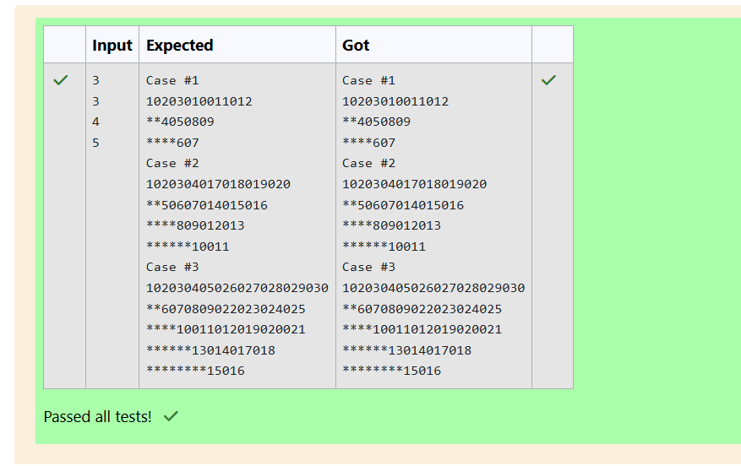
Week 5-2:
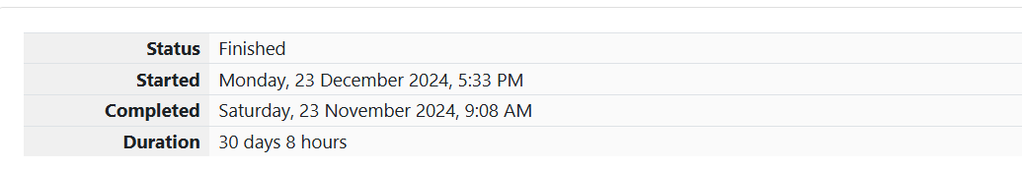

1. Problem : Armstrong Number
Problem Statement:
A kkk-digit number NNN is an Armstrong number if and only if the sum of each of its digits raised to the kkk-th power equals NNN.
Hint:
For example, 153153153 is a 3-digit Armstrong number because:
153=13+53+33=153153 = 1^3 + 5^3 + 3^3 = 153153=13+53+33=153
Constraints:
1≤N≤1081 \leq N \leq 10^81≤N≤108
Input Format:
- A single integer NNN.
Output Format:
- Print true if the number is an Armstrong number, otherwise print false.

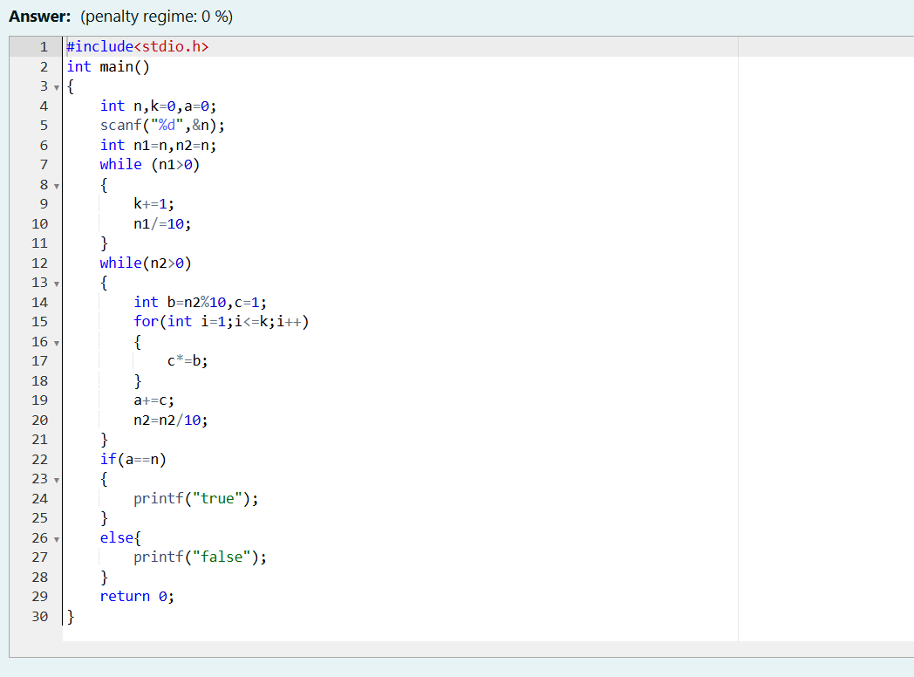
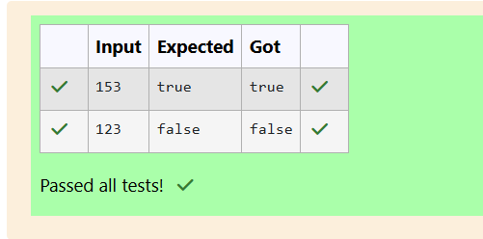

2. Problem : Reverse and Add Until Get a Palindrome
Problem Statement:
Take a number, reverse it, and add it to the original number. Repeat this process until the obtained number is a palindrome.
Constraints:
1≤num≤99,999,9991 \leq num \leq 99,999,9991≤num≤99,999,999
Input Format:
- A single integer numnumnum.
Output Format:
- The resulting palindrome after applying the process.

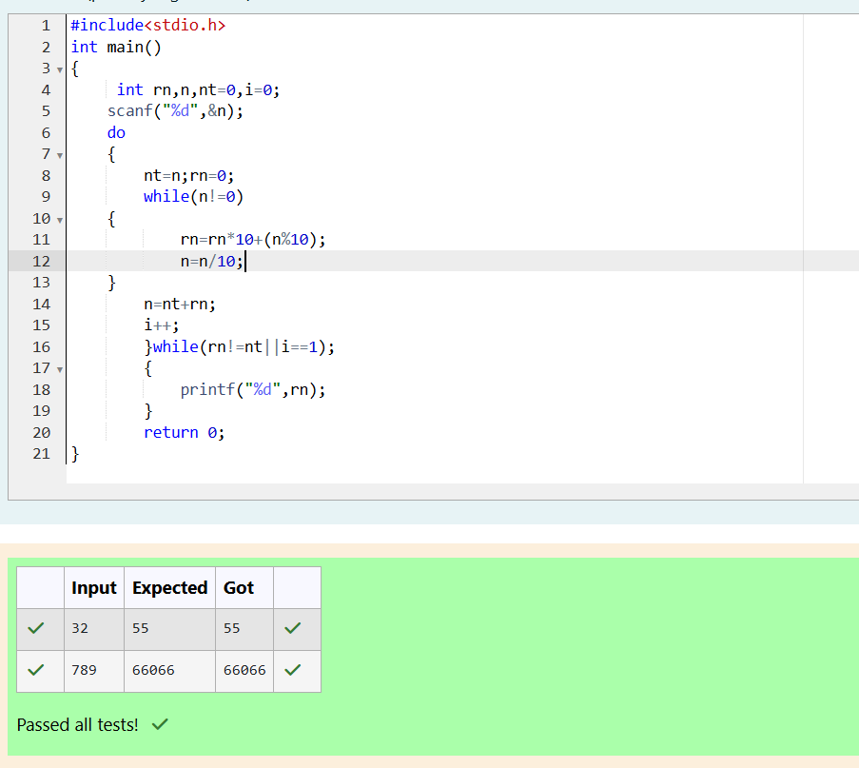

3. Problem : Lucky Number
Problem Statement:
A number is considered lucky if it contains either 3, 4, or both. Write a program to print the nnn-th lucky number.
For example:
1st lucky number = 3
2nd lucky number = 4
3rd lucky number = 33, etc.
Input Format:
- A single integer nnn.
Output Format:
- Print the nnn-th lucky number

